1. | a) | Define energy and power signals. Sketch the signal  x(t) = A[u(t + 4) – u(t – 4)]  Also determine whether the signal is energy or power signal. | 2+6
 | b) | Check the linearity of the following systems  i) y (n) = a x(n) + b  ii) y (n) = e^{x(n)} | 7
2. | a) | Define continuous-time Fourier Transform. Find the Fourier Transform of the following  - Unit Step Function, u(t)  - Signum Function, sgn(t) | 2+6
 | b) | Determine the exponential Fourier Series for the impulse train.  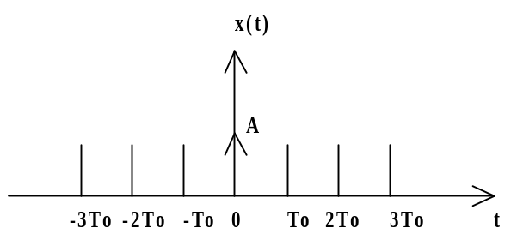 | 7
3. | a) | Prove convolution property of continuous time Fourier Transform. | 7
 | b) | Define Circular Convolution & Zero Padding. Also perform Circular Convolution of the following two sequences  X₁[n] = {1, 2, 4, 3} & X₂ [n] = {2, 5, 3, 6} | 2+6
4. | a) | Find 4-point DFT of the sequence  x(n)= u(n) + u(n-2) – u(n-3) | 7
 | b) | What is an LTI system. Prove that “a LTI system is stable if its impulse response is absolutely summable”. | 2+6
5. | a) | A continuous - time signal x(t) is applied to the input of this LTI system where x(t) = e^{-at} u(t) for a>0 and h(t) = u(t). Evaluate the output y(t) | 7
 | b) | What are the basic elements of continuous-time & discrete-time LTI system. Draw the block diagram representation of the discrete-time LTI system described by input-output relationship as  y(n) = 0.25y(n-1) + 0.5x(n) + 0.5x(n-1) | 4+4
6. | a) | Obtain the Direct Form I & Direct Form II structures for the difference equation given by  2y(n) + y(n-1) – 4y(n-3) = x(n) + x(n-5)  Also represent it by SFG for both Direct Form I & Direct Form II. | 15
7 |  | Write short notes on (any two): | (2*5)
- Signal and System
- Radix 2 FFT Algorithm
- IIR vs FIR

